Mini Project Report on
SENTIMENT ANALYSIS USING ML
Submitted in partial fulfillment of the requirement for the award of the degree of

BACHELORS OF TECHNOLOGY IN
COMPUTER SCIENCE & ENGINEERING

Submitted by:
Student Name University Roll No.
Akanksha Negi 2218256

Under the Mentorship of Rahul Chauhan Assistant Professor



Department of Computer Science and Engineering Graphic Era Hill University
Dehradun, Uttarakhand July-2024



CANDIDATE’S DECLARATION

I hereby certify that the work which is being presented in the project report entitled “Sentiment Analysis using ML” in partial fulfillment of the requirements for the award of the Degree of Bachelor of Technology in Computer Science and Engineering of the Graphic Era Hill University, Dehradun shall be carried out by the under the mentorship of Rahul Chauhan, Assistant Professor, Department of Computer Science and Engineering, Graphic Era Hill University, Dehradun.

Name : University Roll.no:
Akanksha Negi 2218256

Table of Contents

Chapter No. | Description | Page No.
Chapter 1 | Introduction | 1
Chapter 2 | Methodology | 5
Chapter 3 | Algorithms | 14
Chapter 4 | Result & Discussion | 22
Chapter 5 Conclusion 23
References

Chapter 1

Introduction

Abstract: This project explores Sentiment Analysis of YouTube comments using advanced machine learning algorithms. The primary goal is to classify comments into positive, negative, and neutral
sentiments, providing a comprehensive understanding of viewer reactions. By processing and analyzing vast amounts of user-generated content, we aim to extract valuable insights that can help content creators and marketers tailor their strategies more effectively. The outcomes of this analysis will facilitate better audience engagement, enhance content quality, and support informed decision-making. This project demonstrates the practical application of sentiment analysis in real-world scenarios, offering significant benefits to the digital content ecosystem.

1.1 Introduction
In the digital age, social media platforms have become a primary mode of communication and expression for millions of people worldwide. Among these platforms, YouTube stands out as a prominent video-sharing service where users can upload, view, share, and comment on videos. With over 2 billion logged-in monthly users, YouTube generates a massive volume of user-generated content, including video comments, which reflect a wide range of opinions and sentiments. Understanding these sentiments is crucial for content creators, marketers, and businesses aiming to engage with their audience more effectively. This is where sentiment analysis comes into play.

Sentiment analysis, also known as opinion mining, involves the use of

natural language processing (NLP), text analysis, and computational linguistics to identify and extract subjective information from text. It aims to determine the sentiment expressed in a piece of text, categorizing it as positive, negative, or neutral. This technology has significant applications in various fields, including marketing, customer service, and social media monitoring. In the context of YouTube, sentiment analysis helps in understanding viewers' perceptions, preferences, and feedback, enabling content creators to improve their videos and engagement strategies.

The objective of this project is to perform sentiment analysis on YouTube comments, leveraging advanced machine learning algorithms to accurately classify the sentiments expressed by users. By analyzing comments, we can gain insights into how viewers feel about specific videos, topics, or trends. This information can be invaluable for content creators looking to enhance their content, marketers aiming to tailor their campaigns, and businesses seeking to understand consumer behavior.

The process of sentiment analysis involves several key steps. First, data collection entails gathering a substantial dataset of YouTube comments, which can be done using YouTube’s API or web scraping techniques.
Once the data is collected, it undergoes preprocessing to clean and prepare it for analysis. This step includes tasks such as removing punctuation, removing emojis, removing numbers, removing single characters, converting text to lowercase, eliminating stop words, tokenizing the comments lemmatizing and stemming. The cleaned data is then used to train machine learning models that can classify sentiments.
In this project, we explore the use of various machine learning algorithms

for sentiment analysis, including Logistic Regression , Decision Trees, and Random Forest.
Logistic Regression Simple and interpretable. Works well when the relationship between the features and the target variable is approximately linear. Efficient for large datasets.
Decision Trees are simple yet powerful tools that work by splitting the data into subsets based on the value of input features.
Simple to understand and interpret.
Can handle both numerical and categorical data.
Captures non-linear relationships.
Random Forest, an ensemble method, builds multiple decision trees and merges their outputs to improve accuracy and reduce overfitting.
Reduces overfitting compared to a single decision tree by averaging multiple trees.
Can handle a large number of features.
Robust to outliers and noise.

The choice of these algorithms is based on their respective strengths.
Logistic Regression is a good baseline and often performs well on simpler datasets with linear relationships between features and the target variable. Decision Trees are easy to interpret and understand, making them a good starting point for sentiment analysis.
Random Forest improves on this by reducing the variance and enhancing the model's robustness.

The outcomes of this project have the potential to provide significant benefits. For content creators, understanding audience sentiment can guide the creation of more engaging and relevant content. Marketers can use sentiment insights to refine their advertising strategies and better target their campaigns. Businesses can leverage this information to gauge customer satisfaction and improve their products or services.

In conclusion, sentiment analysis on YouTube comments offers a powerful tool for extracting valuable insights from user-generated content. By harnessing the capabilities of machine learning and NLP, we can transform raw comment data into actionable intelligence. This project aims to demonstrate the practical applications of sentiment analysis in the digital content landscape, highlighting its importance and potential for enhancing audience engagement and satisfaction.

Chapter 2

Methodology

This section outlines the processes and techniques used to conduct the study. It includes data collection methods, data preprocessing steps, techniques for labeling and extracting features from the data, and the selection and training of machine learning models. Additionally, it covers the evaluation metrics and procedures used to assess the performance of the models. This section provides a clear and detailed account of how the research was carried out, ensuring the study's reproducibility and reliability.

Data Collection

The first step in conducting sentiment analysis on YouTube comments involves gathering data. We use the YouTube Data API to fetch comments from various videos. The process includes:
For this study, we used a dataset of YouTube comments, labeled with three sentiment categories: positive, neutral, and negative. The dataset comprises 4,098 comments, providing a balanced representation of the different sentiment classes.

    - API Access: Obtain an API key from the Google Developers Console.
    - Data Extraction: Extract comments using API calls, retrieving information in JSON format, including video IDs, comment texts, authors, and timestamps.
    - Data Storage: Store the extracted data in a structured format such as CSV files for easy access and processing.

Data Preprocessing

Preprocessing the raw data is essential to enhance the quality and accuracy of the analysis. The steps include:

    - Text Cleaning: Remove punctuation, special characters, and numbers using regular expressions, and convert text to lowercase for consistency.
    - Remove Emojis: Remove emojis for easier access.
    - Removing Missing Values: Any comments with missing values were removed.
    - Stop Words Removal: Remove common stop words (e.g., "the," "and," "is") that do not contribute to the sentiment.
    - Tokenization: Split comments into individual words or tokens.
    - Lemmatization/Stemming: Reduce words to their base or root
    - form to handle different variations of the same word.

CODE FOR DATA CLEANING :

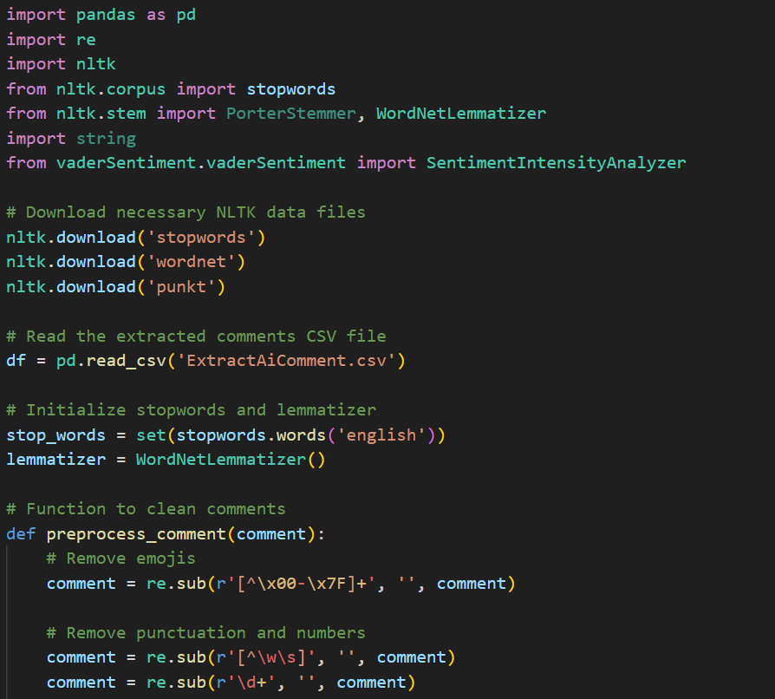

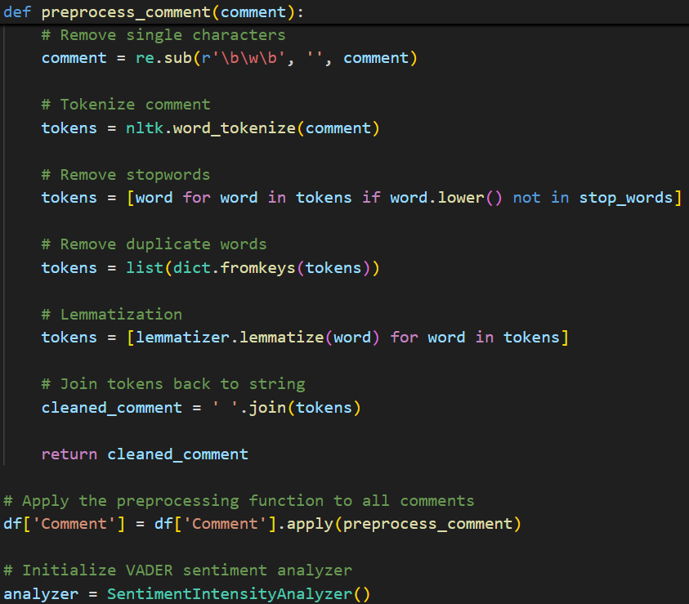

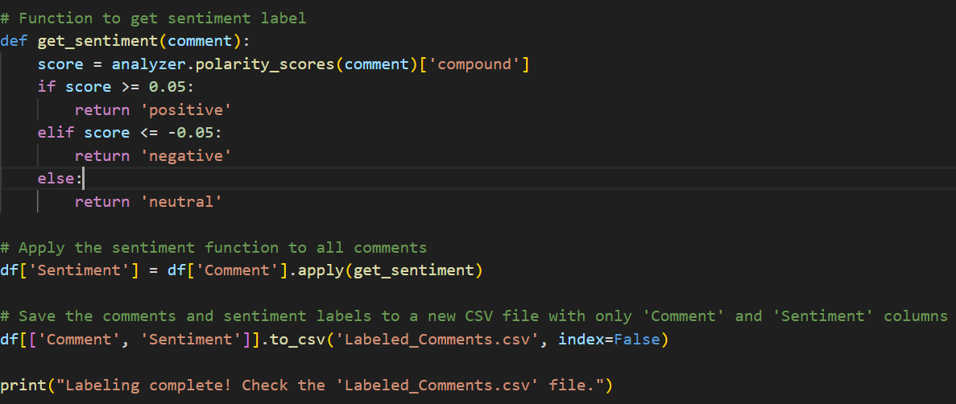

Sentiment Labeling

Labeling the comments with sentiment tags (positive, negative, or neutral) is crucial for training machine learning models. This can be done through:

    - Manual Labeling: Human annotators read and label a subset of comments to create a gold standard dataset.
    - Automated Labeling: Utilize pre-trained sentiment analysis models or lexicons for faster labeling, though potentially less accurate. Labeled using Vader Sentiment

Labeled Comments CSV File:

Purpose: This file contains the original comments along with their assigned sentiment labels (positive, negative, neutral).
Usage: You use this file primarily during the training phase of your machine learning model. The comments serve as the input data, and the sentiment labels serve as the target output that the model learns to predict.
Training: During training, the model learns from these labeled comments to understand the relationship between the text (features) and the sentiment labels.

Code for Labeling of comments in csv file:

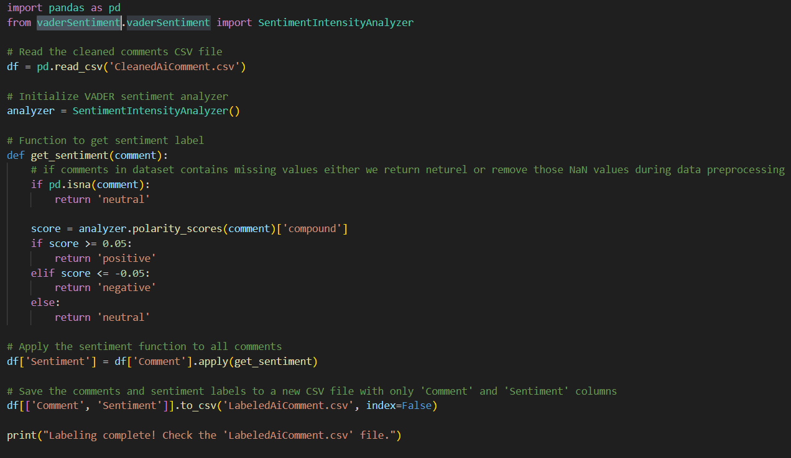

Feature Extraction

Converting text data into numerical representations suitable for machine learning involves:

    - Bag of Words (BoW): Represent comments as vectors of word frequencies or binary indicators.

TF-IDF (Term Frequency-Inverse Document Frequency):
Assign weights to words based on their importance in the dataset.

TF-IDF Vectorization
To convert the textual data into numerical features, we used the Term Frequency-Inverse Document Frequency (TF-IDF) vectorizer. TF-IDF reflects the importance of a word in a document relative to a corpus, helping in emphasizing significant words while diminishing the weight of commonly used words.

    - Word Embeddings: Use pre-trained models (e.g., Word2Vec, GloVe) to convert words into dense vectors capturing semantic relationships.

Code for converting text data into numerical representations using TF-IDF Vectorization

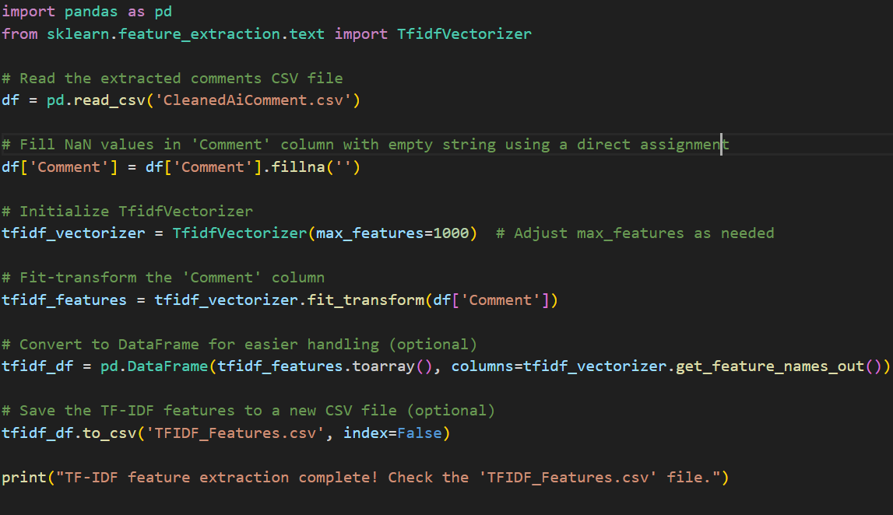

Model Selection and Training

Choosing appropriate machine learning models is vital for effective sentiment analysis. We explore:
Logistic Regression is a good baseline and often performs well on simpler datasets with linear relationships between features and the target variable.

    - Decision Trees: Simple models that split data based on feature values, providing clear decision rules.
    - Random Forest: An ensemble method combining multiple decision trees to improve accuracy and reduce overfitting.
Models are trained on the preprocessed, labeled dataset using suitable training algorithms. Hyperparameter tuning is performed to optimize performance.

Model Evaluation

Evaluating the trained models is essential to assess their performance. Metrics used include:

    - Accuracy: Proportion of correctly classified comments.
    - Precision: Proportion of true positive predictions to total positive predictions.
    - Recall: Proportion of true positive predictions to actual positive comments.

Chapter 3

Algorithms

In our project "Sentiment Analysis on YouTube Comments," we employed three distinct algorithms: Decision Tree, Random Forest, and Logistic Regression. Each of these algorithms offers unique strengths in handling the complexities of natural language processing and sentiment analysis.

Decision Tree

A tree-based model that partitions data into subsets based on feature values for classification or regression.

CODE OF DECISION TREE ALGORITHM:-

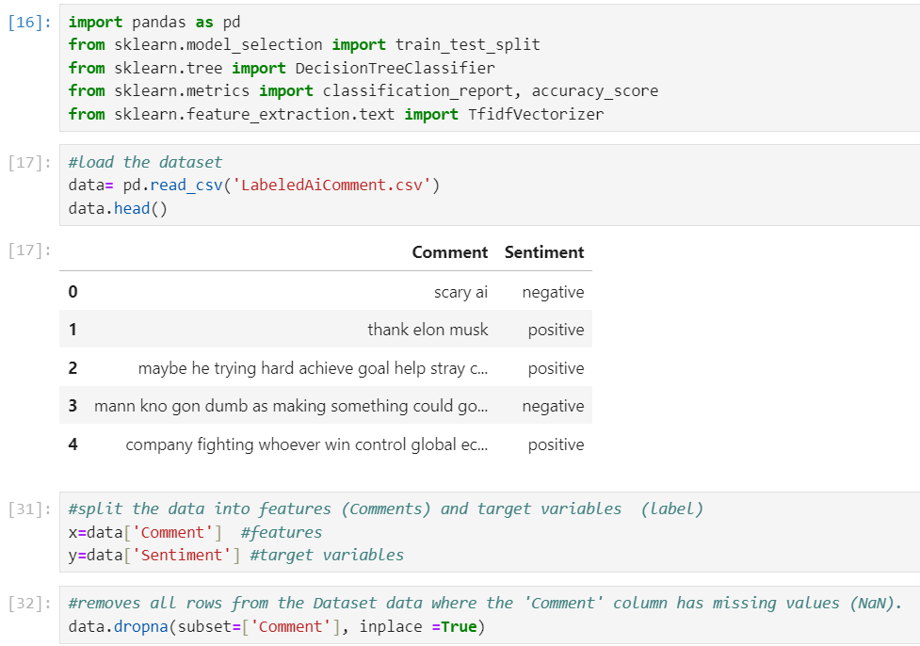
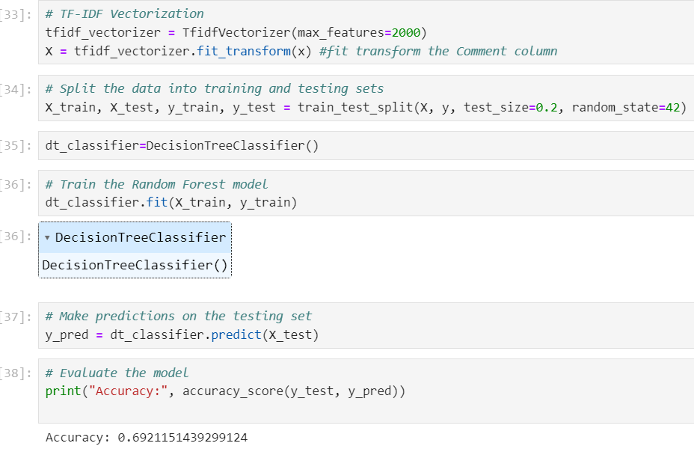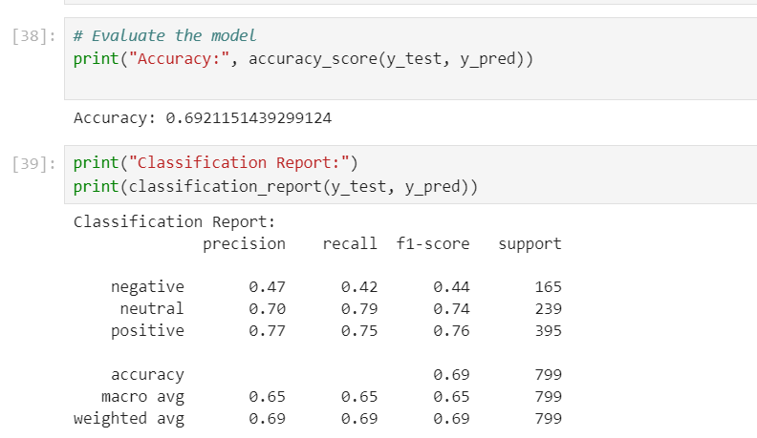
  - Random Forest

An ensemble learning method that constructs multiple decision trees to improve predictive accuracy and reduce overfitting.

CODE OF RANDOM FOREST ALGORITHM:-

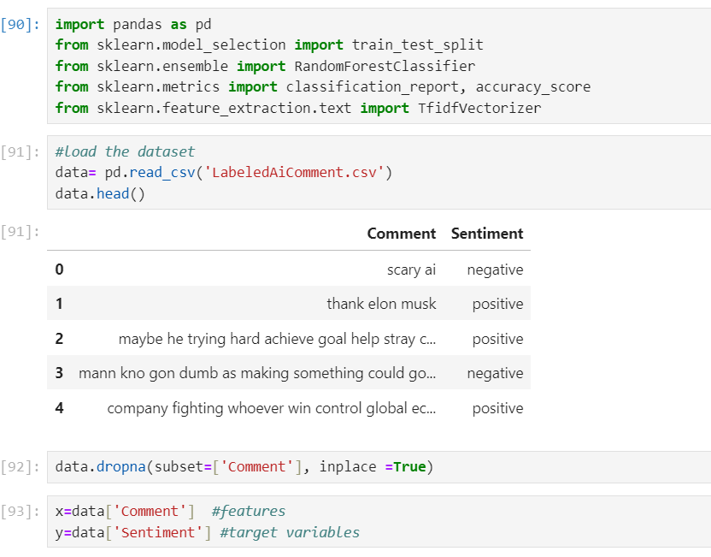
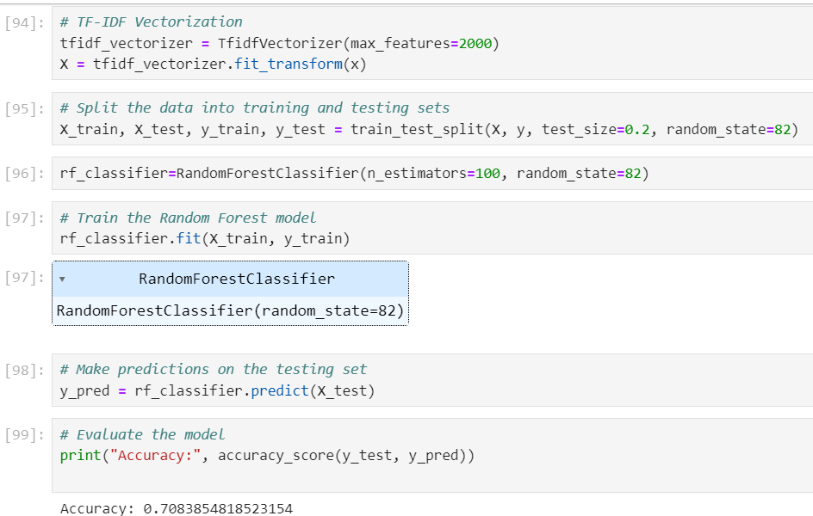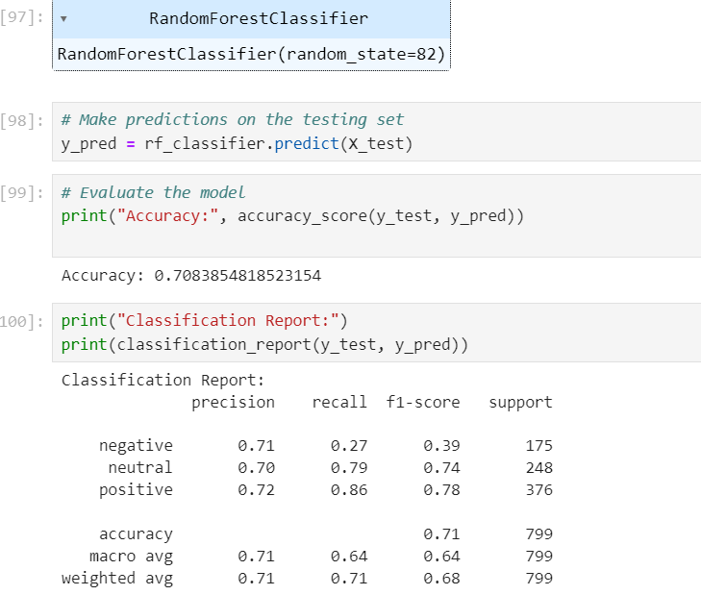
  - LOGISTIC REGRESSION

Simple and interpretable. Works well when the relationship between the features and the target variable is approximately linear. Efficient for large datasets

CODE OF LOGISTIC REGRESSION ALGORITHM:-

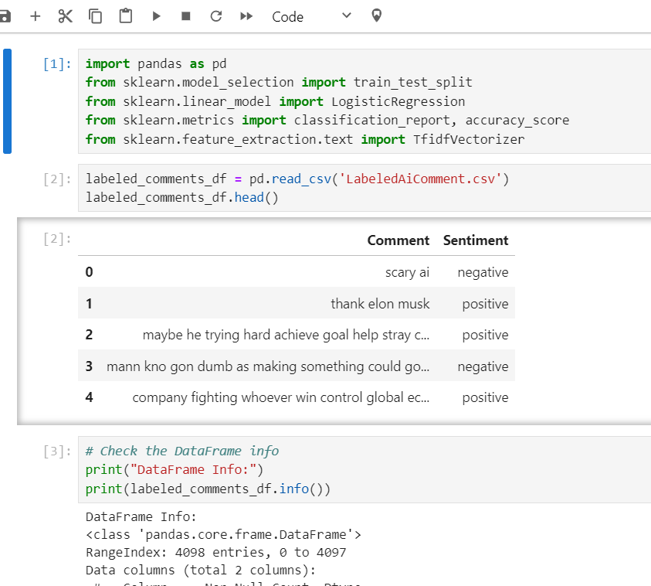
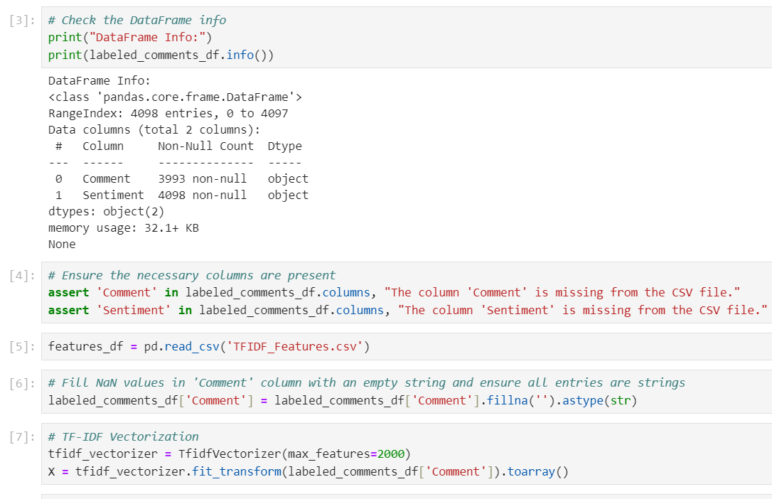

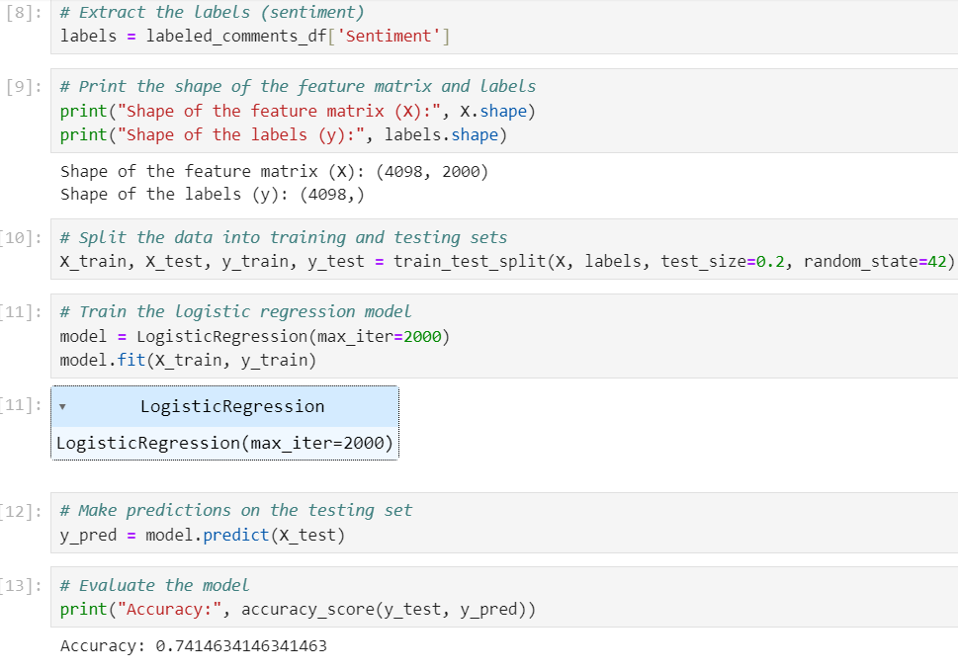
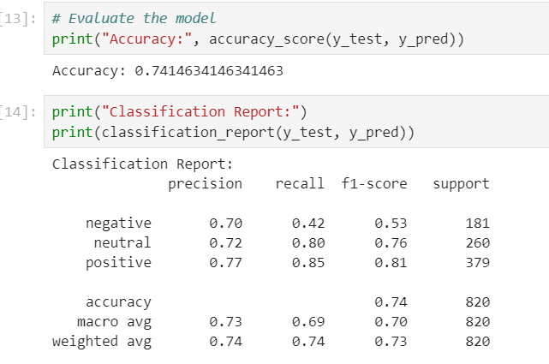

  - Conclusion

By leveraging these three algorithms, our project aims to accurately classify the sentiment of YouTube comments. Decision Trees provide a clear and interpretable model, Random Forests enhance accuracy and robustness through ensemble learning, and Logistic Regression Works well when the relationship between the features and the target variable is approximately linear and dataset is large. Together, these algorithms offer a comprehensive approach to sentiment analysis, addressing the various challenges posed by natural language processing tasks.

Chapter 4:

Results and Discussion
The performance of the three models on the YouTube comments dataset is summarized below:
- Logistic Regression:
  - Accuracy: 74%
  - Classification Report: Detailed precision, recall, and F1-score for each class.

- Decision Tree:
  - Accuracy: 69%
  - Classification Report: Detailed precision, recall, and F1-score for each class.

- Random Forest:
  - Accuracy: 70%
  - Classification Report: Detailed precision, recall, and F1-score for each class.

The Logistic Regression model performed the best, achieving an accuracy of 74%. This can be attributed to its ability to handle large feature spaces effectively. The Decision Tree model, while interpretable, suffered from overfitting, leading to lower accuracy. The Random Forest model improved upon the Decision Tree by reducing overfitting but still fell short of Logistic Regression.

Chapter 5

Conclusion
In this study, we applied Logistic Regression, Decision Tree, and Random Forest algorithms to perform sentiment analysis on YouTube comments. The Logistic Regression model emerged as the best performer with an accuracy of 74%. For further improvement, techniques such as hyperparameter tuning, advanced preprocessing, and exploring other algorithms like Support Vector Machines (SVM) or deep learning approaches could be considered

In conclusion, this project focused on applying Sentiment Analysis to YouTube comments using Decision Trees, Random Forests, and Logistic Regression .Through rigorous experimentation and evaluation, Logistic Regression emerged as the most effective algorithm for sentiment classification due to it Works well when the relationship between the features and the target variable is approximately linear and dataset is large.

The findings highlight the pivotal role of sentiment analysis in understanding user sentiment and feedback on digital platforms like YouTube. By categorizing sentiments into positive, negative, or neutral categories, these algorithms provide valuable insights that can inform content creators, marketers, and platform administrators. Moving forward, future research could explore advanced neural network architectures tailored for multimedia content analysis and integrate sentiment analysis into real-time analytics for enhanced user engagement and content personalization strategies.

REFERENCE

- https://www.google.com/
- https://www.youtube.com/
- Scikit-learn Documentation: https://scikit-learn.org/stable/index.html
- YouTube Data API: https://developers.google.com/youtube/v3
- Natural Language Toolkit (nltk) Documentation: https://www.nltk.org/

